

# Computer & Electronic Engineering

# Final Year Project "Music Host Interface"

# Sprint 8: Week 1 Log

# Thomas Flynn

# Project Supervisor: Brian O'Shea

# 04/04/16 - 10/03/16

# 1 Log Entries

## 1.1.0 Entry 1: 04/04/16

Today I got both the DJ comment and the skip song feature working.

## 1.2.0 Entry 2: 05/04/16

Today I got the basics of the logout feature working.

## 1.3.0 Entry 3: 06/04/16

Today I spent considerable time on the look and feel of my FX GUI.

# 2 GIT Repositories:

## 2.1 FYP-GUI

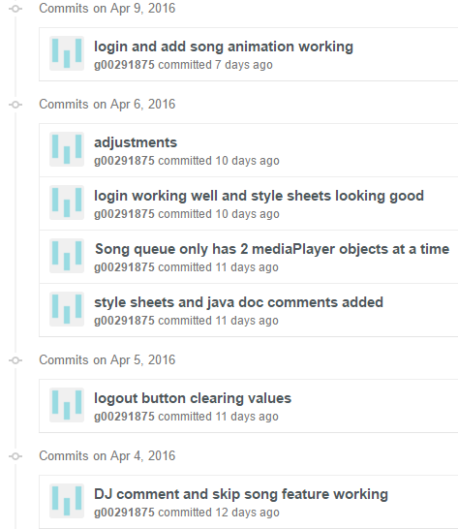

## 2.2 FYP-Android

## C:\year 5\Project Year 5 Documentation\Weekly screenshots\Sprint 8\wk1\androidgit.PNG

# 3 Toggl Time Logs

## 3.1 Weekly time Log bar chart:

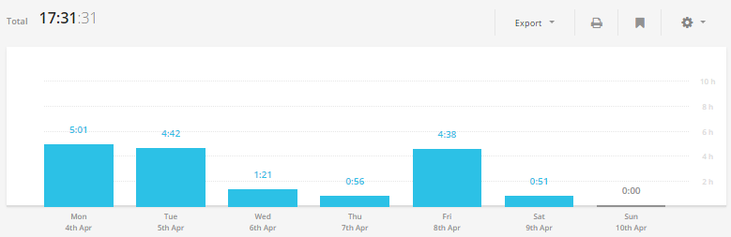

## 3.2 Weekly Time Log:

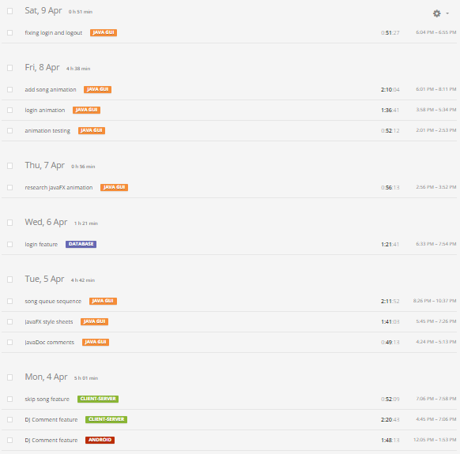

## 3.3Weekly log Pie Charts:

